AI STUDY BUDDY API

Submitted By:

Team ID : SWTID-2026-5289
Team Size : 5
Team Leader : ANISHA S
Team member : ARISHA S
Team member : VIJAYALAKSHMI M
Team member : SANTHOSHINI P
Team member : YOGALAKSHMI D

INTRODUCTION

Education is increasingly becoming technology-driven, and Artificial Intelligence is being used to support students in different stages of the learning process. Students often have to work with textbooks, lecture notes, PDF documents, presentations, and other learning materials. Understanding and revising large amounts of information requires significant time and effort.
The AI Study Buddy API is developed to address this problem by providing an intelligent backend service that converts study materials into useful learning resources.
The system allows a student to upload study material and request different types of learning assistance. Instead of manually preparing notes, flashcards, questions, and schedules, the student can use the API to generate these resources automatically.

PROJECT OVERVIEW

AI Study Buddy API is a backend-focused project. It acts as an intermediate layer between the student-facing application and the AI service. The API provides intelligent features such as question answering, concept explanations, flashcards, quiz generation, study plan and learning support based on the student’s input.
The backend is responsible for processing the uploaded material, validating requests, communicating with external AI services, and returning structured responses.
The main objective of the project is to create a scalable and easy-to-integrate API that improves the learning experience by making AI-powered academic assistance accessible through a single platform.

NEED FOR THE PROJECT
Students commonly face the following difficulties:
- Large study materials are difficult to revise quickly.
- Preparing notes manually takes time.
- Creating flashcards manually requires additional effort.
- Students may find it difficult to prepare practice quizzes.
- Creating a consistent study schedule can be challenging.
- Learning resources are often distributed across multiple files and applications.
AI StudyBuddy provides an integrated approach to these requirements.

SCOPE OF THE PROJECT
The project primarily focuses on backend functionality.
The major scope includes:
- File upload handling
- Study material processing
- AI integration
- Summary generation
- Flashcard generation
- Quiz generation
- Study plan generation
- API request and response management
- Error handling
- Database integration where required

The API can later be integrated with a web application, mobile application, or other educational platforms.

PROBLEM STATEMENT
Students face difficulties in organizing study materials, understanding lengthy content, and preparing for exams. AI StudyBuddy addresses these challenges by providing a centralized platform for storing materials and accessing AI-powered learning assistance.
OBJECTIVES
- To provide a centralized platform for study materials.
- To enable AI-based question answering.
- To generate summaries and quizzes from learning content.
- To provide personalized learning assistance.
- To simplify access to educational resources through APIs.

SOFTWARE REQUIREMENTS

- Operating System - Windows / Linux / macOS
- Code Editor - Visual Studio Code
- Backend Runtime - Node.js
- Backend Framework - Express.js
- Database - MongoDB
- API Testing - Postman
- AI Service - AI API

TECHNOLOGIES USED

1. Node.js :
Node.js provides the runtime environment for executing the backend application. It supports asynchronous operations and is suitable for developing API-based applications.
2. Express.js :
Express.js can be used as the backend framework to create REST API endpoints, handle HTTP requests, implement middleware, and manage responses.
3. Database :
A database can be used to store required application information such as user details, uploaded material information, study history, generated resources, and timestamps.
4. AI API :
The AI service is the core intelligence layer of the application. The backend sends relevant study content and instructions to the AI service and receives generated learning resources.
5.Postman:
Postman is used to test the backend endpoints by sending requests and examining the generated responses.
6. Visual Studio Code:
Visual Studio Code is used as the primary development environment for writing, organizing, and debugging the backend source code.

SYSTEM ARCHITECTURE

Client Layer :
The client sends requests to the backend API. It can be a web application, mobile application, or testing tool such as Postman.
API Layer :
The API receives requests and routes them to the appropriate functionality.
Validation Layer :
The backend checks whether the request contains valid input data.
Service Layer :
The service layer contains the main application logic and communicates with external AI services or databases.
AI Layer :
The AI service processes the study content and generates the requested learning resource.
Database Layer :
The database stores information required by the application.

PROJECT EXECUTION
The AI StudyBuddy backend can be executed locally using Node.js. Before running the application, ensure that MongoDB is running and the required environment variables are configured correctly. The backend exposes REST APIs that can be tested using Postman or Thunder Client.
Running the Backend Server
npm install
npm start
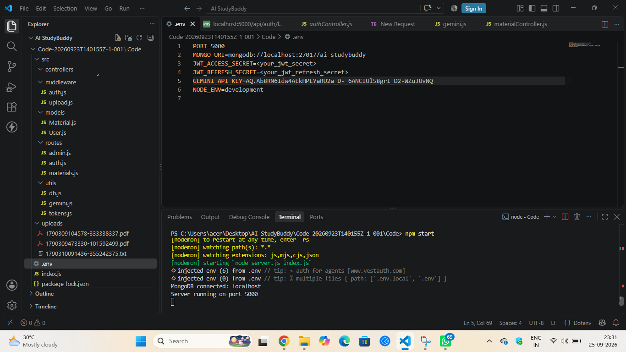

API Testing

The backend APIs can be tested using Postman.

1. User Registration

Registers a new user by accepting the required details and securely storing the encrypted password in the MongoDB database.

Endpoint: POST /api/auth/register
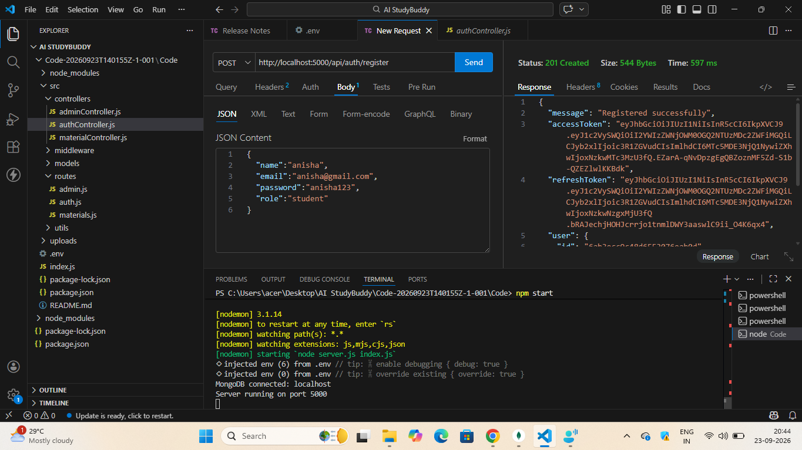

2. User Login
Authenticates the registered user and generates a JWT access token for accessing protected APIs.
Endpoint:
POST /api/auth/login

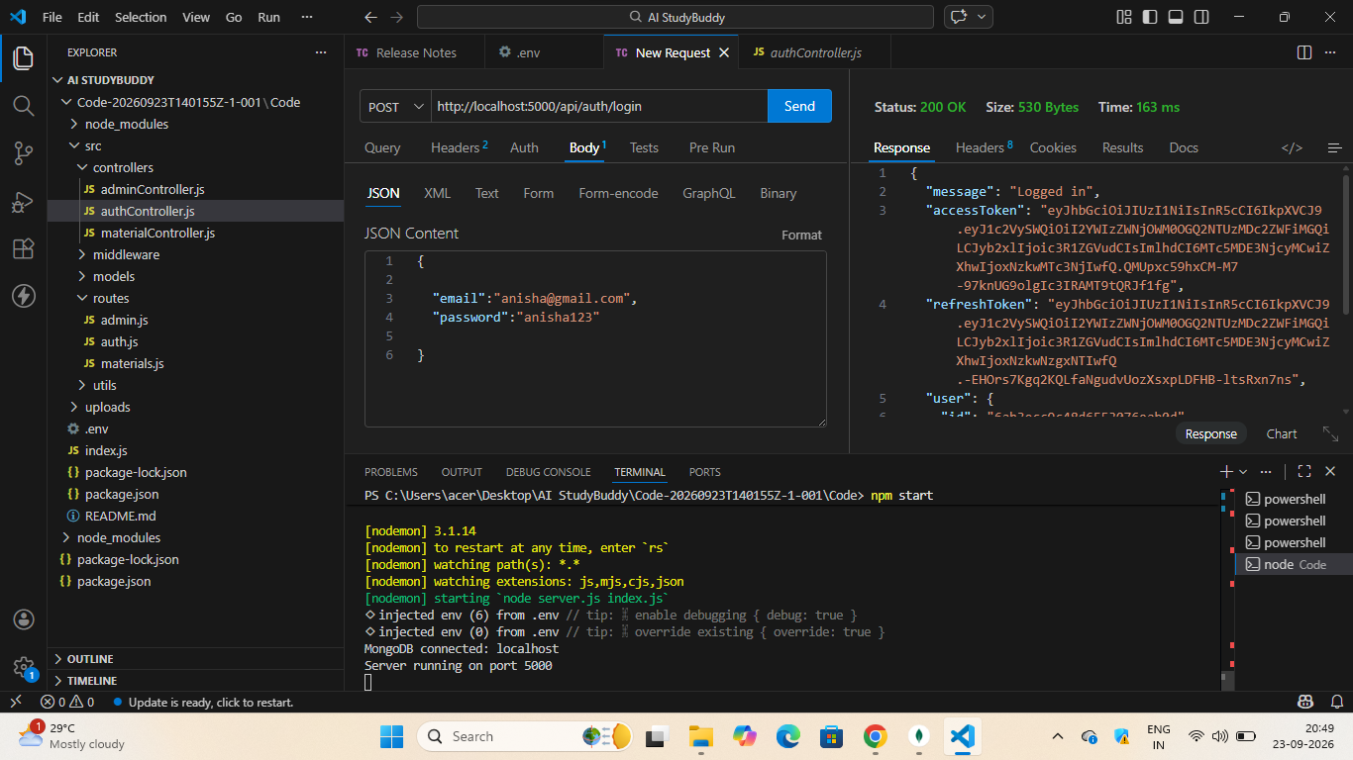
3. Upload Study Material
Allows authenticated users to upload study material that will be used as input for AI-powered content generation.
Endpoint: POST /api/material/upload

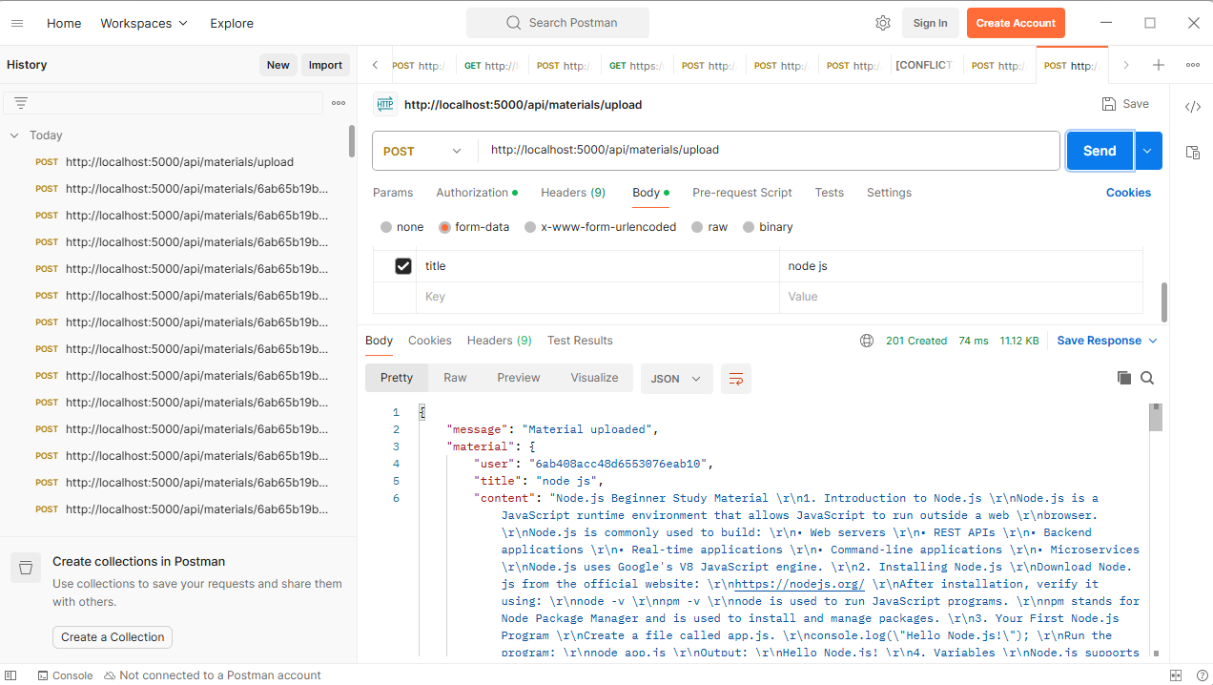

4.Get materials:
The system retrieves the requested material and provides its details through the API. GET/api/materials/
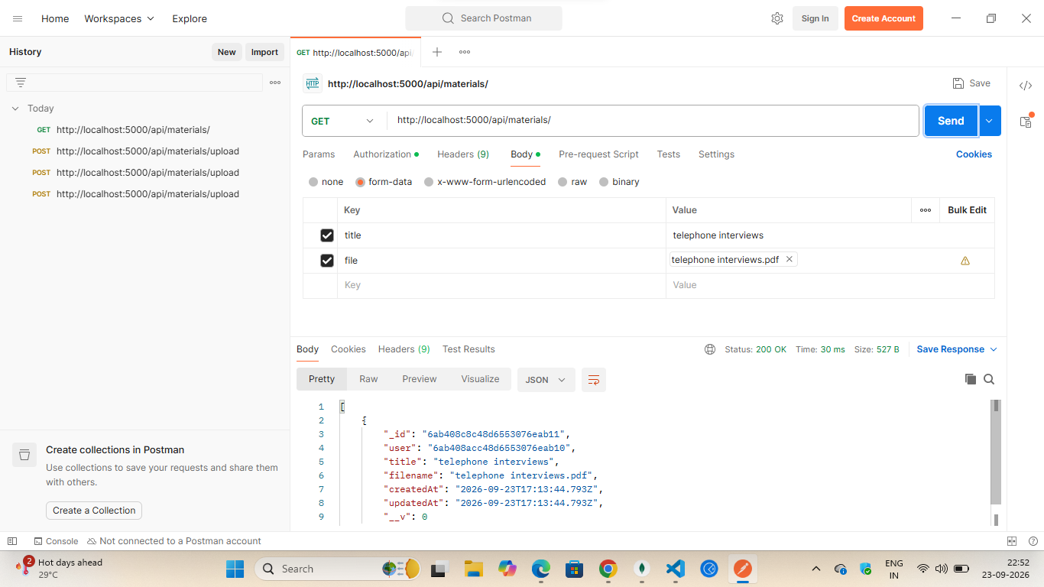

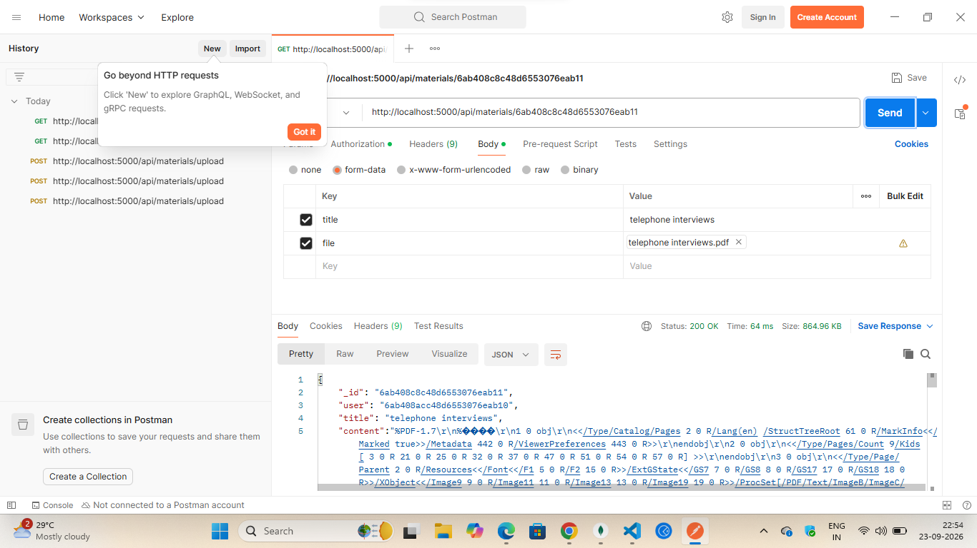

4. Generate AI Summary
Sends the uploaded study material to the Google Gemini API and generates a concise summary.
Endpoint: POST /api/materials/:id/summarize
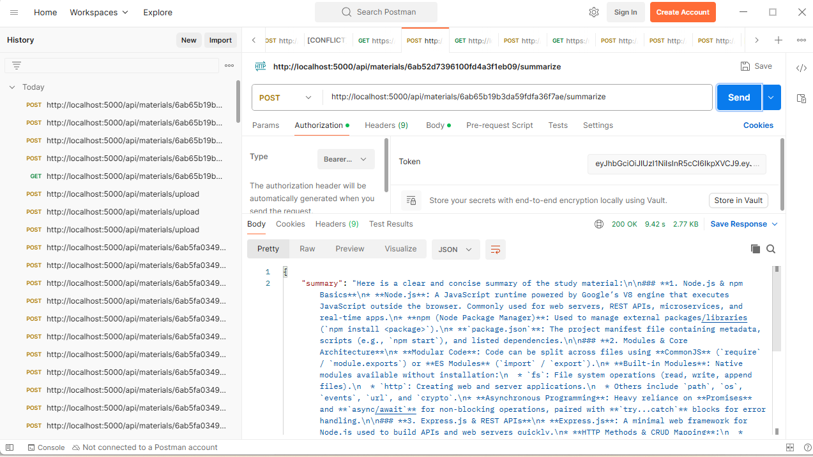

5. Generate AI Flashcards
Creates AI-generated flashcards from the uploaded study material for effective revision.
Endpoint: POST /api/ai/flashcards
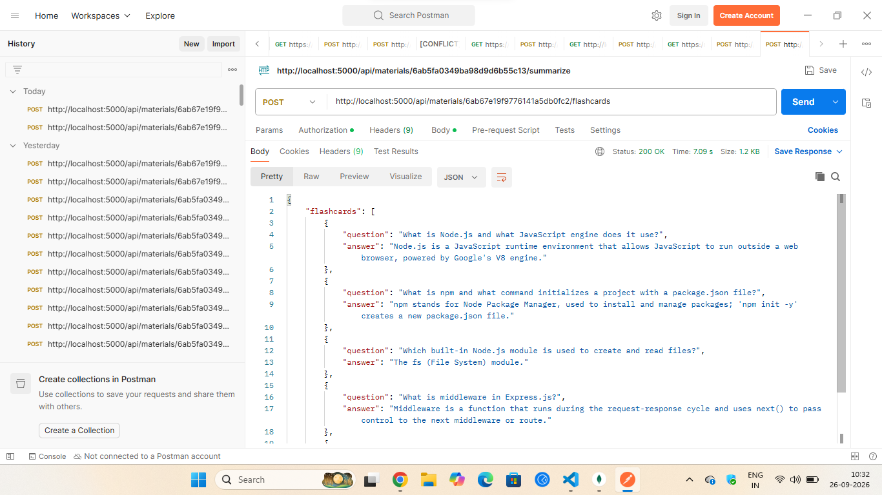
6. Generate AI Quiz
Generates multiple-choice questions from the uploaded study material to help users assess their understanding.
Endpoint:POST /api/ai/quiz
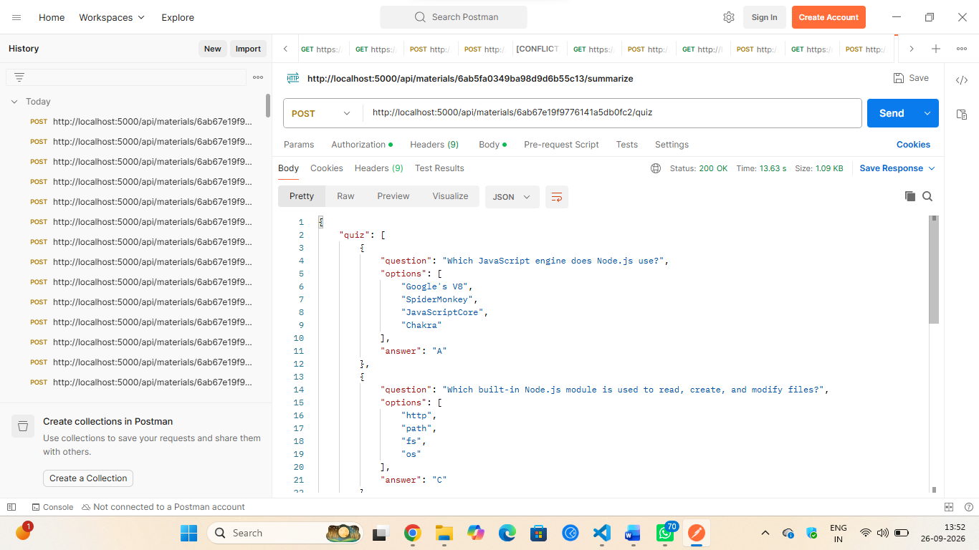

7. Generate AI Study Plan
Creates a personalized study schedule based on the user's learning goals and available study time.
Endpoint: POST /api/ai/study-plan
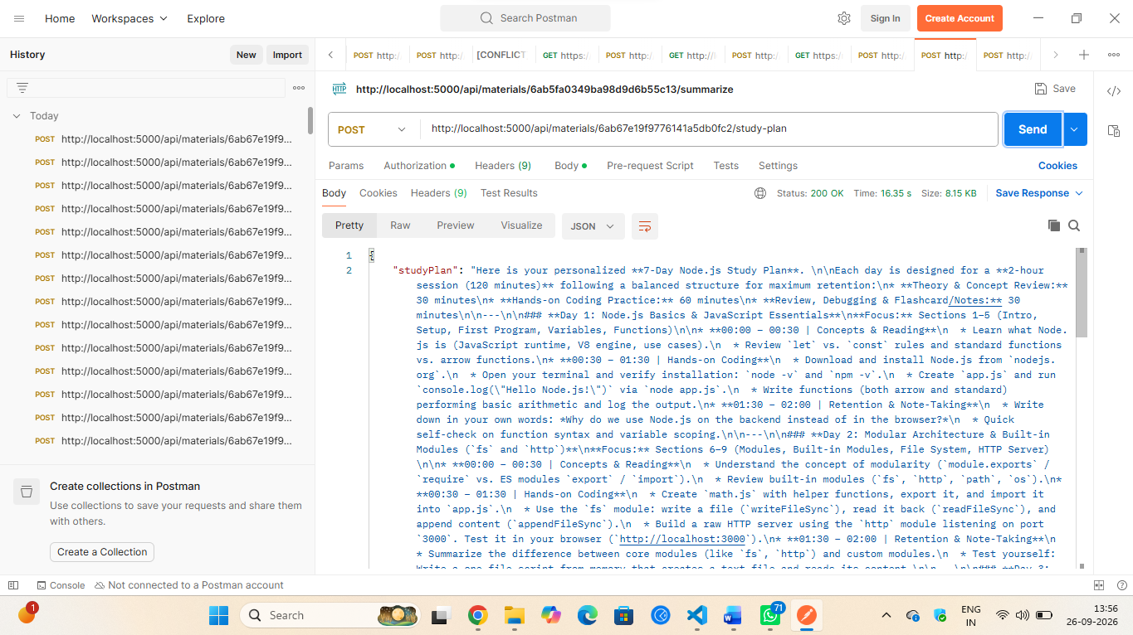

DEMO VIDEO LINK:
https://drive.google.com/file/d/1OfhAKLE3F7MQFmL7zaIQRstBi1OCmdF3/view?usp=drive_link

ADVANTAGES
- Provides a centralized platform for managing study materials.
- Helps students understand learning content using AI-powered assistance.
- Reduces the time required to search and organize study resources.
- Supports quick generation of summaries and quizzes.
- Provides personalized learning support based on student requirements.
- REST API architecture makes the system easy to integrate with web and mobile applications.
- Improves the overall study and revision experience.

LIMITATIONS
- The quality of AI-generated responses depends on the quality of the input material.
- AI-generated information may sometimes require verification from reliable academic sources.
- The system may depend on internet connectivity when using external AI services.
- Large study documents may require additional processing time.
- The initial version may support only selected file formats.

FUTURE ENHANCEMENTS
- Add voice-based interaction for hands-free learning.
- Support multiple languages for better accessibility.
- Introduce image-based question answering for diagrams and handwritten questions.
- Develop a dedicated mobile application.
- Add advanced learning analytics to track student performance.
- Implement personalized and adaptive study plans based on learning progress.
- Add recommendation features to suggest relevant study materials automatically.
- Integrate additional AI models and educational resources.

CONCLUSION
AI StudyBuddy API provides an AI-powered platform that simplifies the process of learning and revising study materials. The system combines material management, authentication, and AI-based educational assistance through a structured REST API. Features such as material upload, content retrieval, question answering, summarization, and quiz generation can help students access learning support more efficiently.
The project demonstrates how AI and API-based technologies can be combined to create a flexible educational system. With further enhancements such as voice interaction, multilingual support, mobile integration, and personalized learning analytics, AI StudyBuddy can be extended into a more comprehensive learning platform.

